Converse in Geometry

Definition
# Source: AI Source: Provided by: [Data Path: Persons Table -> ID Column: 1, Name_En Column: Motasem Essam] -> From: [ChatGPT] on [7/25/2026]
A Converse in geometry is a statement obtained by interchanging the hypothesis and conclusion of a conditional statement.
If the original statement has the form:
$$\boxed{P⇒Q}$$
then its converse is:
$$\boxed{Q⇒P}$$
In words:
The converse reverses the direction of the original conditional statement.

Simple Definition
# Source: AI Source: Provided by: [Data Path: Persons Table -> ID Column: 1, Name_En Column: Motasem Essam] -> From: [ChatGPT] on [7/25/2026]
A converse is formed by switching the given condition and the conclusion of a geometric statement.

Basic Structure
# Source: AI Source: Provided by: [Data Path: Persons Table -> ID Column: 1, Name_En Column: Motasem Essam] -> From: [ChatGPT] on [7/25/2026]
Original Statement
$$\boxed{P⇒Q}$$
Converse
$$\boxed{Q⇒P}$$
For example:
Original:
If two lines are perpendicular, then they form a right angle.
$$\text{Perpendicular}⇒{90}^{∘}\text{ angle}$$
Converse:
If two intersecting lines form a right angle, then the lines are perpendicular.
$${90}^{∘}\text{ angle}⇒\text{Perpendicular}$$

Main Types of Converses in Geometry
# Source: AI Source: Provided by: [Data Path: Persons Table -> ID Column: 1, Name_En Column: Motasem Essam] -> From: [ChatGPT] on [7/25/2026]
A practical classification is:
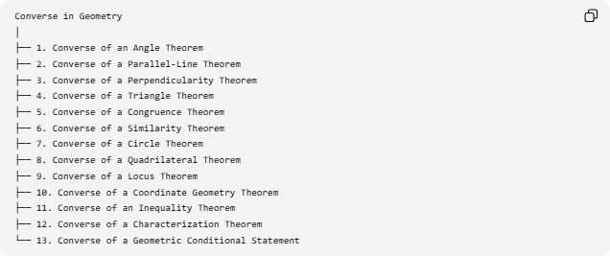
Converse in Geometry
│
├── 1. Converse of an Angle Theorem
├── 2. Converse of a Parallel-Line Theorem
├── 3. Converse of a Perpendicularity Theorem
├── 4. Converse of a Triangle Theorem
├── 5. Converse of a Congruence Theorem
├── 6. Converse of a Similarity Theorem
├── 7. Converse of a Circle Theorem
├── 8. Converse of a Quadrilateral Theorem
├── 9. Converse of a Locus Theorem
├── 10. Converse of a Coordinate Geometry Theorem
├── 11. Converse of an Inequality Theorem
├── 12. Converse of a Characterization Theorem
└── 13. Converse of a Geometric Conditional Statement
This classification is based on what type of geometric statement is being reversed.

1. Converse of an Angle Theorem
# Source: AI Source: Provided by: [Data Path: Persons Table -> ID Column: 1, Name_En Column: Motasem Essam] -> From: [ChatGPT] on [7/25/2026]
Example
Original statement:
If two angles are vertical angles, then they are congruent.
$$\boxed{\text{Vertical Angles}⇒\text{Congruent Angles}}$$
Its converse would be:
If two angles are congruent, then they are vertical angles.
$$\text{Congruent Angles}⇒\text{Vertical Angles}$$
This converse is false.
For example, two adjacent ${50}^{∘}$angles are congruent but are not vertical angles.
Important Lesson
A converse is not automatically true.

2. Converse of a Parallel-Line Theorem
# Source: AI Source: Provided by: [Data Path: Persons Table -> ID Column: 1, Name_En Column: Motasem Essam] -> From: [ChatGPT] on [7/25/2026]
A very important example comes from transversal angle relationships.
Original
If two parallel lines are cut by a transversal, then corresponding angles are congruent.
$$\boxed{l_{1}∥l_{2}⇒\text{Corresponding angles are congruent}}$$
Converse
If corresponding angles are congruent, then the two lines are parallel.
$$\boxed{\text{Corresponding angles are congruent}⇒l_{1}∥l_{2}}$$
This converse is a valid theorem under the appropriate configuration.
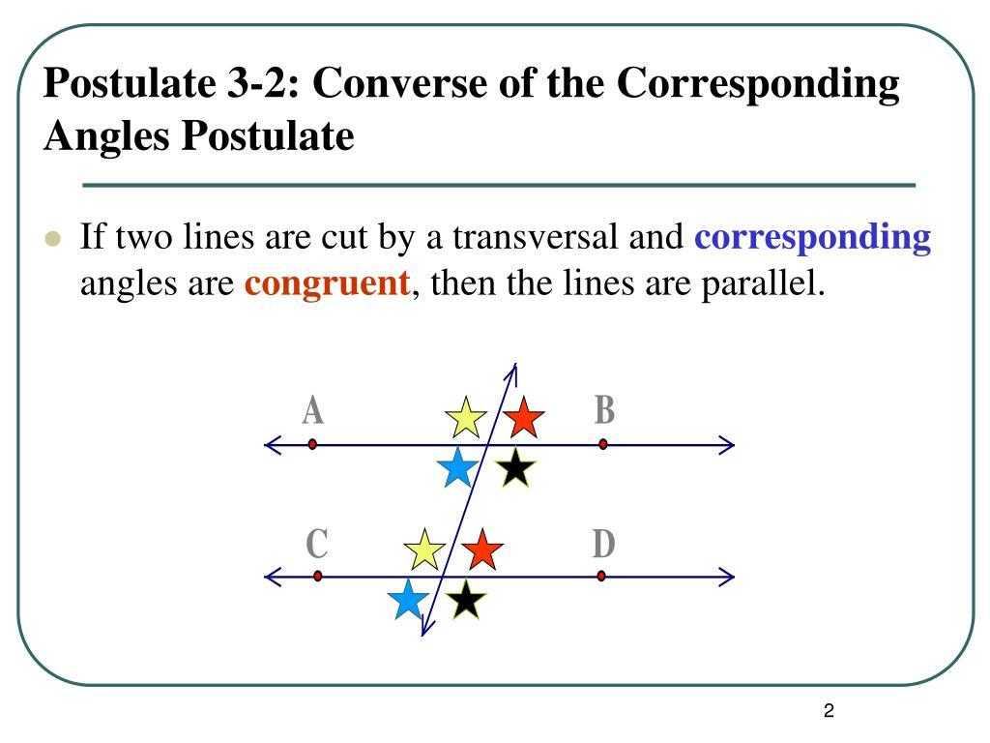
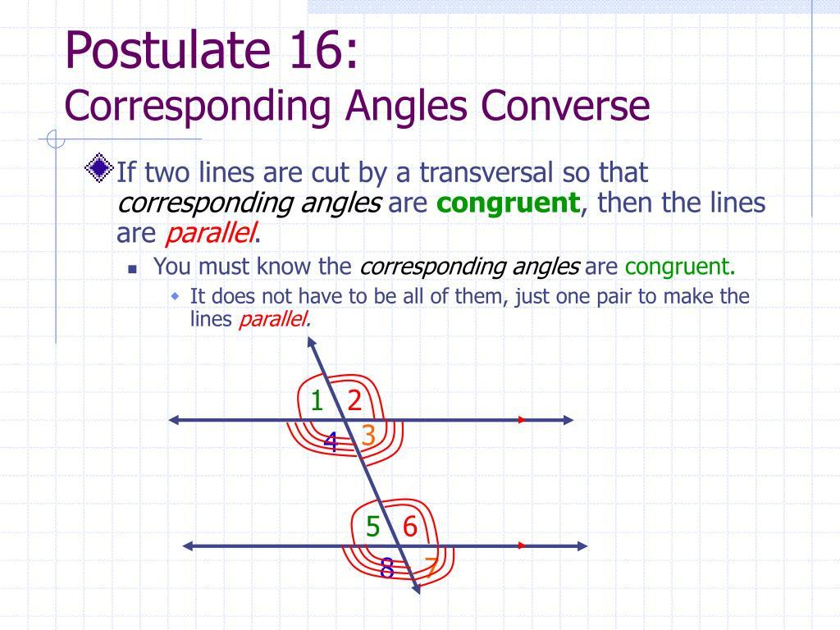
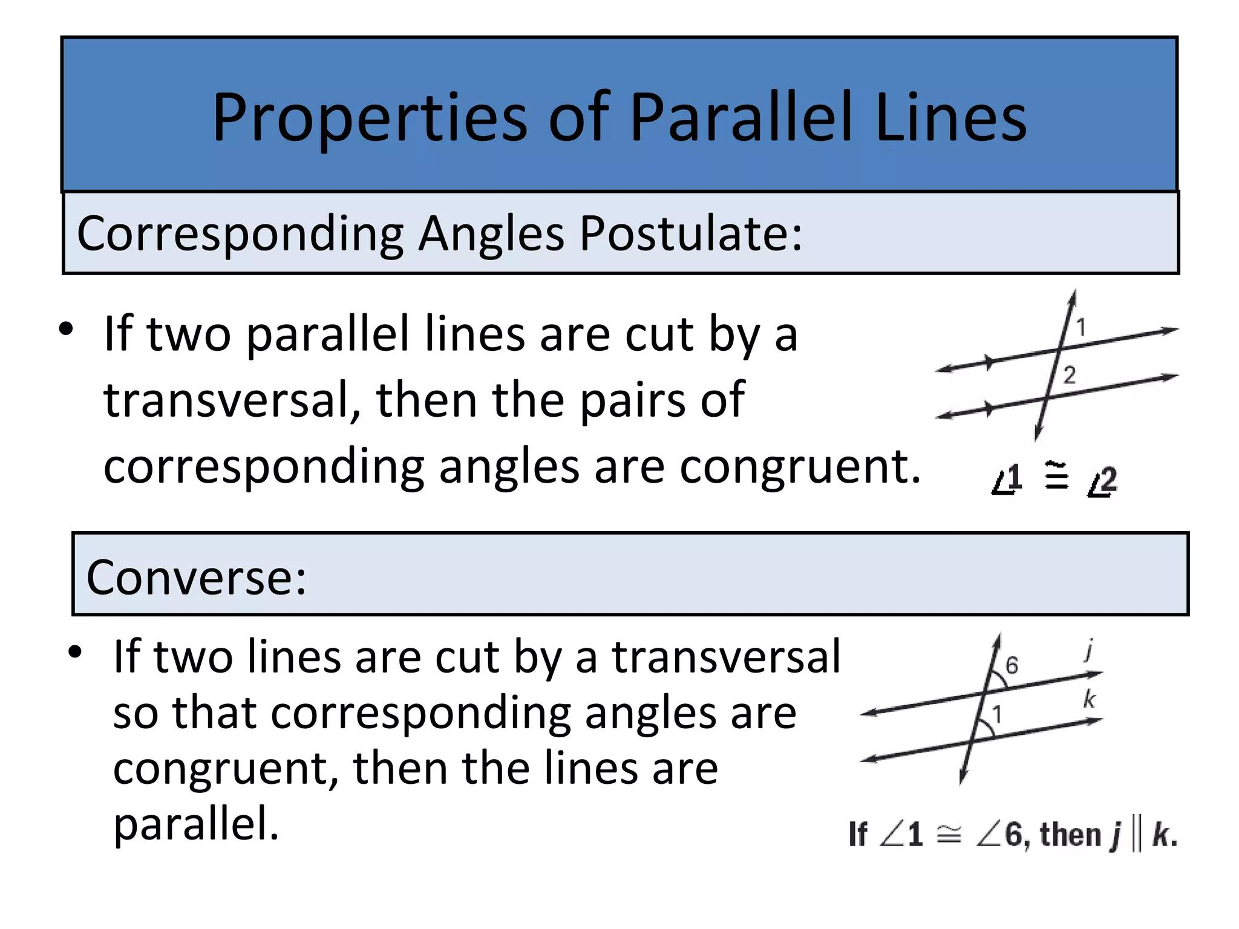
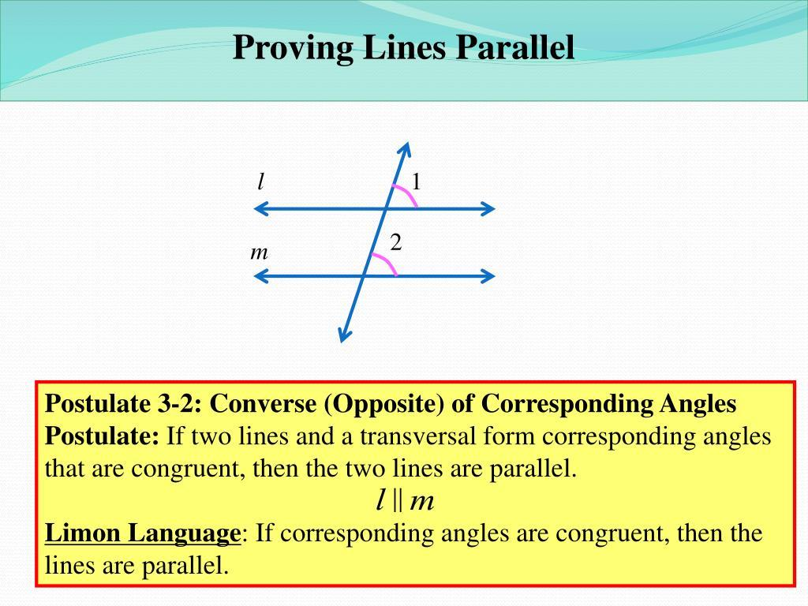
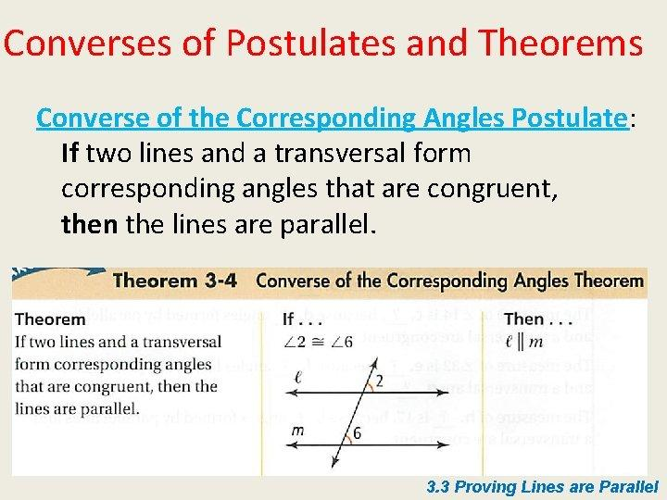
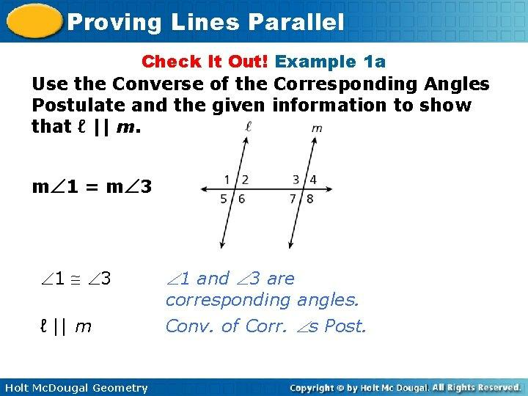
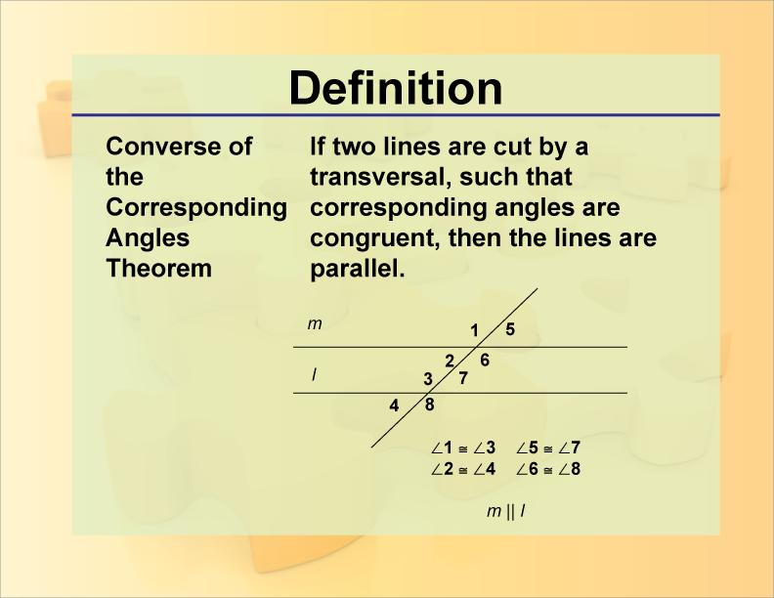

3. Converse of a Perpendicularity Theorem
# Source: AI Source: Provided by: [Data Path: Persons Table -> ID Column: 1, Name_En Column: Motasem Essam] -> From: [ChatGPT] on [7/25/2026]
Original
If two lines are perpendicular, then they form a right angle.
$$\boxed{l_{1}⊥l_{2}⇒m∠={90}^{∘}}$$
Converse
If two intersecting lines form a right angle, then they are perpendicular.
$$\boxed{m∠={90}^{∘}⇒l_{1}⊥l_{2}}$$
This converse is true.

4. Converse of a Triangle Theorem
# Source: AI Source: Provided by: [Data Path: Persons Table -> ID Column: 1, Name_En Column: Motasem Essam] -> From: [ChatGPT] on [7/25/2026]
Example: Isosceles Triangle Theorem
Original:
If two sides of a triangle are congruent, then the opposite angles are congruent.
$$\boxed{AB=AC⇒∠B=∠C}$$
Converse:
If two angles of a triangle are congruent, then the opposite sides are congruent.
$$\boxed{∠B=∠C⇒AB=AC}$$
This converse is also true.

5. Converse of a Congruence Statement
# Source: AI Source: Provided by: [Data Path: Persons Table -> ID Column: 1, Name_En Column: Motasem Essam] -> From: [ChatGPT] on [7/25/2026]
Consider:
If two triangles are congruent, then their corresponding sides are congruent.
$$△ABC≅△DEF⇒AB=DE$$
The reverse statement:
$$AB=DE⇒△ABC≅△DEF$$
is not generally true.
Knowing only one pair of corresponding sides is not enough to prove triangle congruence.
You would need a valid criterion such as:
$$SSS, SAS, ASA, AAS, HL$$

6. Converse of a Similarity Statement
# Source: AI Source: Provided by: [Data Path: Persons Table -> ID Column: 1, Name_En Column: Motasem Essam] -> From: [ChatGPT] on [7/25/2026]
Suppose:
$$△ABC∼△DEF$$
then corresponding sides are proportional:
$$\frac{AB}{DE}=\frac{BC}{EF}=\frac{AC}{DF}$$
A valid converse similarity theorem can be obtained when sufficient corresponding relationships are established.
For example, if:
$$\frac{AB}{DE}=\frac{BC}{EF}=\frac{AC}{DF}$$
then:
$$\boxed{△ABC∼△DEF}$$
This is the SSS Similarity Converse.

7. Converse of a Circle Theorem
# Source: AI Source: Provided by: [Data Path: Persons Table -> ID Column: 1, Name_En Column: Motasem Essam] -> From: [ChatGPT] on [7/25/2026]
Example: Thales' Theorem
Original:
If $AC$is a diameter of a circle and $B$lies on the circle, then $∠ABC={90}^{∘}$.
$$\boxed{AC\text{ is a diameter}⇒∠ABC={90}^{∘}}$$
Converse:
If $B$lies on the circle and $∠ABC={90}^{∘}$, then $AC$is a diameter.
$$\boxed{∠ABC={90}^{∘}⇒AC\text{ is a diameter}}$$
This is a valid converse.

8. Converse of a Quadrilateral Theorem
# Source: AI Source: Provided by: [Data Path: Persons Table -> ID Column: 1, Name_En Column: Motasem Essam] -> From: [ChatGPT] on [7/25/2026]
Example: Parallelogram
One characterization states:
If the diagonals of a quadrilateral bisect each other, then the quadrilateral is a parallelogram.
$$\boxed{\text{Diagonals bisect each other}⇒\text{Parallelogram}}$$
Another direction is:
If a quadrilateral is a parallelogram, then its diagonals bisect each other.
$$\boxed{\text{Parallelogram}⇒\text{Diagonals bisect each other}}$$
These two directions together give an if and only if characterization:
$$\boxed{\text{Parallelogram}⇔\text{Diagonals bisect each other}}$$

9. Converse of a Locus Theorem
# Source: AI Source: Provided by: [Data Path: Persons Table -> ID Column: 1, Name_En Column: Motasem Essam] -> From: [ChatGPT] on [7/25/2026]
Locus theorems frequently have useful converses.
Example
Original:
Every point on the perpendicular bisector of $\overset{‾}{AB}$is equidistant from $A$and $B$.
$$P∈\text{perpendicular bisector}⇒PA=PB$$
Converse:
Every point equidistant from $A$and $B$lies on the perpendicular bisector of $\overset{‾}{AB}$.
$$PA=PB⇒P∈\text{perpendicular bisector}$$
Therefore:
$$\boxed{PA=PB⇔P\text{ lies on the perpendicular bisector of }AB}$$

10. Converse in Coordinate Geometry
# Source: AI Source: Provided by: [Data Path: Persons Table -> ID Column: 1, Name_En Column: Motasem Essam] -> From: [ChatGPT] on [7/25/2026]
Coordinate geometry also uses converse reasoning.
Example
For two nonvertical lines:
$$m_{1}=m_{2}$$
implies the lines are parallel, provided they are distinct.
The converse relationship can be expressed as:
$$\boxed{l_{1}∥l_{2}⇒m_{1}=m_{2}}$$
and, under the stated conditions:
$$\boxed{m_{1}=m_{2}⇒l_{1}∥l_{2}}$$
The conditions matter: coincident lines also have the same slope, so the lines must be distinct if the conclusion is specifically "parallel."

11. Converse of an Inequality Statement
# Source: AI Source: Provided by: [Data Path: Persons Table -> ID Column: 1, Name_En Column: Motasem Essam] -> From: [ChatGPT] on [7/25/2026]
Converse reasoning can also appear in geometric inequalities, but reversing an inequality statement does not automatically produce a true statement.
For example:
$$a+b>c$$
is necessary for three positive lengths to form a triangle.
But simply reversing a particular implication involving this inequality requires checking whether the converse is actually valid.
This is why the validity of a converse must always be established rather than assumed.

12. Converse of a Characterization Theorem
# Source: AI Source: Provided by: [Data Path: Persons Table -> ID Column: 1, Name_En Column: Motasem Essam] -> From: [ChatGPT] on [7/25/2026]
Characterization theorems are especially useful because they often establish both directions.
Suppose:
$$P⇒Q$$
and:
$$Q⇒P$$
Then:
$$\boxed{P⇔Q}$$
This means:
$P$if and only if $Q$.
Example
For a perpendicular bisector:
$$\boxed{P\text{ lies on perpendicular bisector of }AB⇔PA=PB}$$
Both directions have been established.

How to Find the Converse
# Source: AI Source: Provided by: [Data Path: Persons Table -> ID Column: 1, Name_En Column: Motasem Essam] -> From: [ChatGPT] on [7/25/2026]
Take a conditional statement:
If $P$, then $Q$.
Identify:
- Hypothesis: $P$
- Conclusion: $Q$
Then switch them.
Original
$$P⇒Q$$
Converse
$$Q⇒P$$
Example
Original:
If a triangle is equilateral, then it is isosceles.
$$\boxed{\text{Equilateral}⇒\text{Isosceles}}$$
Converse:
If a triangle is isosceles, then it is equilateral.
$$\boxed{\text{Isosceles}⇒\text{Equilateral}}$$
The converse is false.
An isosceles triangle can have side lengths:
$$5, 5, 8$$
It is not equilateral.

Converse vs Inverse vs Contrapositive
# Source: AI Source: Provided by: [Data Path: Persons Table -> ID Column: 1, Name_En Column: Motasem Essam] -> From: [ChatGPT] on [7/25/2026]
These are different operations.
For the original statement:
$$\boxed{P⇒Q}$$
Converse
Switch $P$and $Q$:
$$\boxed{Q⇒P}$$
Inverse
Negate both:
$$\boxed{¬P⇒¬Q}$$
Contrapositive
Switch and negate:
$$\boxed{¬Q⇒¬P}$$
Relationship
The original statement and its contrapositive are logically equivalent:
$$\boxed{P⇒Q ⟺ ¬Q⇒¬P}$$
The converse and inverse are also logically equivalent:
$$\boxed{Q⇒P ⟺ ¬P⇒¬Q}$$
But the converse is not generally equivalent to the original statement.

Summary Table
# Source: AI Source: Provided by: [Data Path: Persons Table -> ID Column: 1, Name_En Column: Motasem Essam] -> From: [ChatGPT] on [7/25/2026]
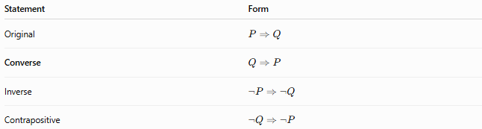
Statement | Form
Original | $$P⇒Q$$
Converse | $$Q⇒P$$
Inverse | $$¬P⇒¬Q$$
Contrapositive | $$¬Q⇒¬P$$

Converse Is Not Automatically True
# Source: AI Source: Provided by: [Data Path: Persons Table -> ID Column: 1, Name_En Column: Motasem Essam] -> From: [ChatGPT] on [7/25/2026]
This is one of the most important ideas.
Suppose:
$$P⇒Q$$
is true.
You cannot automatically conclude:
$$Q⇒P$$
is true.
Example
Original:
If a figure is a square, then it is a rectangle.
$$\boxed{\text{Square}⇒\text{Rectangle}}$$
True.
Converse:
If a figure is a rectangle, then it is a square.
$$\boxed{\text{Rectangle}⇒\text{Square}}$$
False.
A $2×5$rectangle is not a square.

Converse Theorem
# Source: AI Source: Provided by: [Data Path: Persons Table -> ID Column: 1, Name_En Column: Motasem Essam] -> From: [ChatGPT] on [7/25/2026]
When the converse of a theorem is itself true and has been established by proof, it can be stated as a converse theorem.
For example:
Original
$$AB=AC⇒∠B=∠C$$
Converse
$$∠B=∠C⇒AB=AC$$
Both are true, so both can be used as theorems.

Key Logical Structure
# Source: AI Source: Provided by: [Data Path: Persons Table -> ID Column: 1, Name_En Column: Motasem Essam] -> From: [ChatGPT] on [7/25/2026]
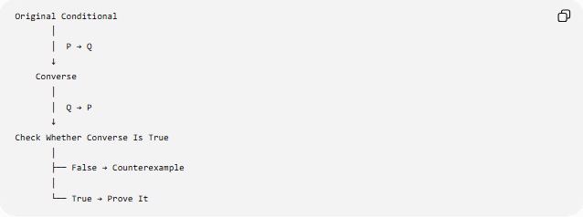
Original Conditional
│
│ P → Q
↓
Converse
│
│ Q → P
↓
Check Whether Converse Is True
│
├── False → Counterexample
│
└── True → Prove It
If both directions are true:
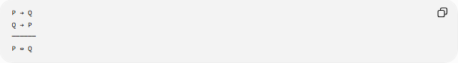
P → Q
Q → P
──────
P ↔ Q
Therefore:
$$\boxed{P⇔Q}$$

Key Points
# Source: AI Source: Provided by: [Data Path: Persons Table -> ID Column: 1, Name_En Column: Motasem Essam] -> From: [ChatGPT] on [7/25/2026]
- A converse is formed by interchanging the hypothesis and conclusion.
- Original:
$$P⇒Q$$
- Converse:
$$Q⇒P$$
- A true theorem does not necessarily have a true converse.
- A converse must be proved if it is to be used as a theorem.
- A counterexample can show that a converse is false.
- When both directions are true, they can be combined into an if and only if statement:
$$\boxed{P⇔Q}$$
- Converse and contrapositive are different concepts.
- The contrapositive is logically equivalent to the original statement, while the converse generally is not.

Conclusion
# Source: AI Source: Provided by: [Data Path: Persons Table -> ID Column: 1, Name_En Column: Motasem Essam] -> From: [ChatGPT] on [7/25/2026]
A Converse in Geometry is obtained by reversing the direction of a conditional geometric statement:
$$\boxed{P⇒Q} ⟶ \boxed{Q⇒P}$$
The most important rule is:
$$\boxed{\text{A true statement does not guarantee a true converse.}}$$
When both the original statement and its converse are true, they form an if-and-only-if relationship:
$$\boxed{P⇔Q}$$

